**ISO 20022**

BMR Administrator and Benchmark Reporting

Approved by the ISO 20022 Securities SEG on the 5th of November 2018.

**Message Definition Report** **- Part 1**

Edition November 2018

Table of contents

1. Introduction 3

1.1 Terms and definitions 3

1.2 Glossary 3

1.3 Document Scope and Objectives 4

1.4 References 4

2. Scope and Functionality 5

2.1 Background 5

2.2 Groups of MessageDefinitions and Functionality 5

2.2.1 Benchmark Data Messages 6

2.2.2 Other Messages 6

3. BusinessRoles and Participants 7

3.1 Participants and BusinessRoles Definitions 7

3.2 BusinessRoles and Participants Table 8

4. BusinessProcess Description 8

4.1 BusinessProcess Diagram 8

4.2 Update Benchmarks Data 8

4.3 Cancel Benchmarks Data 9

5. Description of Business Activities 10

6. BusinessTransactions 12

6.1 BMR Financial party BusinessTransaction 12

6.2 BMR Benchmark BusinessTransaction 12

7. Examples 13

7.1 FinancialSupervisedPartyIdentityReport – auth.076.001.01 13

7.2 FinancialBenchmarkReport – auth.077.001.01 14

8. Revision Record 16

**Preliminary note:**

The Message Definition Report (MDR) is made of three parts:

* **MDR - Part 1** describes the contextual background required to understand the functionality of the proposed message set. Part 1 is produced by the submitting organisation that developed or maintained the message set in line with a MDR Part1 template provided by the ISO 20022 Registration Authority (RA) on [www.iso20022.org](http://www.iso20022.org)
* **MDR – Part 2** is the detailed description of each message definition of the message set. Part 2 is produced by the RA using the model developed by the submitting organisation.
* **MDR – Part 3** is an extract of the ISO 20022 Business Model describing the business concepts used in the message set. Part 3 is an Excel document produced by the RA.

# Introduction

## Terms and definitions

The following terms are reserved words defined in ISO 20022 – Part1. When used in this document, they will follow the UpperCamelCase notation.

|  |  |
| --- | --- |
| Term | Definition |
| BusinessRole | functional role played by a business actor in a particular BusinessProcess or BusinessTransaction |
| Participant | involvement of a BusinessRole in a BusinessTransaction |
| BusinessProcess | unrealized definition of the business activities undertaken by BusinessRoles within a BusinessArea whereby each BusinessProcess fulfils one type of business activity and whereby a BusinessProcess may include and extend other BusinessProcesses |
| BusinessTransaction | particular solution that meets the communication requirements and the interaction requirements of a particular BusinessProcess and BusinessArea |
| MessageDefinition | formal description of the structure of a MessageInstance |

## Glossary

**Acronyms**

|  |  |
| --- | --- |
| Acronym | Definition |
| BAH | Business Application Header |
| BMR | BenchMarks Regulation also called the “local regulation” |
| CA(s) | Competent Authority (ies) |
| EEA | European Economic Area |
| ESMA | European Securities and Markets Authority |
| EU | European Union |
| SA | Supervisory Authority |
| SEG | Standards Evaluation Group |
| SWIFT | Society for Worldwide Interbank Financial Telecommunication |
| TC | Third Country |

**Abbreviations**

|  |  |
| --- | --- |
| Abbreviation | Definition |
| NCA | Any Competent Authority that will have access to the ESMA System and will use it in order to upload benchmarks’ data. |
| ESMA | European Securities and Markets Authority |

## Document Scope and Objectives

This document is the first part of the ISO 20022 Message Definition Report (MDR) that describes the BusinessTransactions and underlying message set. For the sake of completeness, the document may also describe BusinessActivities that are not in the scope of the project.

This document sets:

* The BusinessProcess scope (business processes addressed or impacted by the project)
* The BusinessRoles involved in these BusinessProcesses

The main objectives of this document are:

* To explain what BusinessProcesses and BusinessActivities these MessageDefinitions have addressed
* To give a high level description of BusinessProcesses and the associated BusinessRoles
* To document the BusinessTransactions and their Participants (sequence diagrams)
* To list the MessageDefinitions

## References

| Document | Version | Date | Author |
| --- | --- | --- | --- |
| Regulation (EU) 2016/1011 | 1 | 2016-06-29 | European Parliament and Council |
| Financial instruments and transactions regulatory reporting Business Justification #108 | 1.0 | 23 December 2015 | ESMA |

# Scope and Functionality

## Background

This Message Definition Report covers a set of two (2) ISO 20022 MessageDefinitions developed by European Securities and Markets Authority (ESMA) in close collaboration with SWIFT and submitted to the approval of the ISO 20022 Securities Standards Evaluation Group (SEG).

In the context of BMR, specifically Art.36. that was published in the Official Journal of the European Union and entered into force on 30 June 2016[1], ESMA is required to establish and maintain a public register of financial parties acting as benchmarks’ administrators and third country benchmarks by the date of the entry into application of the BMR, i.e. 1 January 2018. As per Article 3 of the BMR, a ‘benchmark’ means any index by reference to which the amount payable under a financial instrument or a financial contract, or the value of a financial instrument, is determined, or an index that is used to measure the performance of an investment fund with the purpose of tracking the return of such index or of defining the asset allocation of a portfolio or of computing the performance fees.

ESMA has consequently decided to build an IT System composed of a database allowing receiving benchmarks’ data from CAs.

Therefore, after thorough consideration of different options aiming to facilitate the reporting of CAs’ data to ESMA, and with the agreement of all CAs, CAs are required to develop facilities allowing data provision by CAs in the ISO 20022 format[2] and communication with the IT system.

The messages will be used between NCA(s) and ESMA only. These messages are specifically designed to support the data provision of:

* Identification, description, status in the EU/EEA area of Benchmarks [Benchmarks under the local regulation];
* Identification, description, status in the EU/EEA area of financial parties administrating the benchmarks [Financial parties under the local regulation]; and
* Identification, description, status in the EU/EEA area of financial parties endorsing the benchmarks in the EU/EEA area [Financial parties under the local regulation].

## Groups of MessageDefinitions and Functionality

Each reporting agent within the scope of BMR must report benchmarks data on ad-hoc basis.

The messages have been developed both to meet the BMR requirements and also to be generic so that they can be used by similar regulations in use by others. Where something is specific to BMR, a usage has been defined to specify the BMR specific requirement.

The following types of messages are exchanged within the system:

**Group 1:** Benchmark Data Messages. Two data collection messages that contain:

* the information on a financial party which administrate and/or uses a benchmark: auth.076.
* the information on a benchmark which is administrated and/or used by a financial party: auth.077.

**Group 2:** Other Messages

* Status advice (feedback) messages that contain technical information related to the status and potential errors in the collection process implemented between the NCA and the Supervisory Authority.

1. These messages are to be used with the ISO 20022 Business Application Header (head.001). The schema and more information about the Business Application Header (BAH) can be found on the www.iso20022.org web site

### Benchmark Data Messages

|  |  |
| --- | --- |
| **MessageDefinition** | **Message Identifier** |
| Financial Benchmark Report | auth.077 |
| Financial Supervised Party Identity Report | auth.076 |

### Other Messages

To support benchmark data reporting, a number of other ISO messages will be used, such as feedback on the above submitted data, as well as associated reference information to be provided by the Supervisory Authority to National Competent Authorities. These additional messages are:

|  |  |
| --- | --- |
| **MessageDefinition** | **Message Identifier** |
| Financial Instrument Reporting Status Advice | auth.031 |

Please note that auth.031 has been submitted as part of the Financial Instruments and Transactions Regulatory Reporting (Trade Repository Reporting) message set.

# BusinessRoles and Participants

A BusinessRole represents an entity (or a class of entities) of the real world, physical or legal, a person, a group of persons, a corporation. Examples of BusinessRoles: “Financial Institution”, “ACH”, “CSD”.

A Participant is a functional role performed by a BusinessRole in a particular BusinessProcess or BusinessTransaction: for example the “user” of a system, “debtor”, “creditor”, “investor” etc.

The relationship between BusinessRoles and Participants is many-to-many. One BusinessRole (that is, a person) can be involved as different Participants at different moments in time or at the same time: "user", "debtor”, "creditor", "investor", etc. Different BusinessRoles can be involved as the same Participant.

In the context of the Benchmark reporting, the high-level BusinessRoles and typical Participants can be represented as follows.

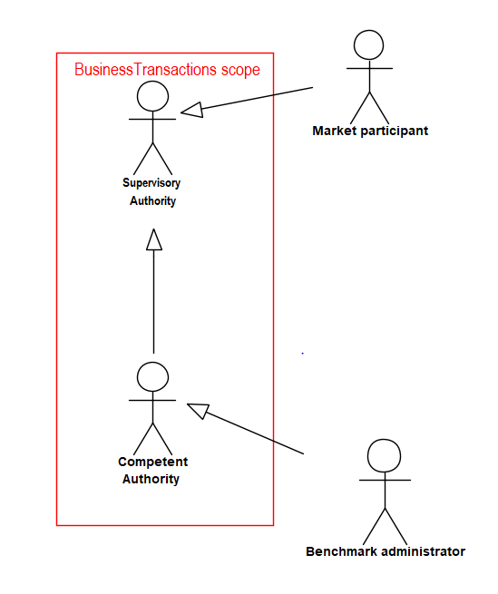

## Participants and BusinessRoles Definitions

| **Participants and BusinessRoles definitions** | |
| --- | --- |
| **Description** | **Definition** |
| **Participants** | |
| Competent Authority | Entity which regulates the financial parties acting as benchmark administrator and the use of benchmarks under its jurisdiction and notifies corresponding data to ESMA. |
| Supervisory Authority | Entity which collects and publishes data from all competent authorities. |
| **BusinessRoles** | |
| ESMA | European Securities and Markets Authority. A Supervisory Authority performing regulatory tasks. |
| NCA | National Competent Authority of each EU/EEA member state or any countries considered as equivalent to the local regulation. |
| Benchmark administrator | A natural or legal person that has control over the provision of a benchmark. |
| Market participant | A natural or legal person that is involved in the financial market. It accesses the list of benchmark administrators and benchmarks published by the Supervisory Authority. When it is a supervised entity, it can use a benchmark in the Union (EU/EEA) when published by the Supervisory Authority.**one of the** [**people**](https://dictionary.cambridge.org/dictionary/english/people) **or** [**companies**](https://dictionary.cambridge.org/dictionary/english/company) **involved in a particular** [**financial**](https://dictionary.cambridge.org/dictionary/english/financial)[**market**](https://dictionary.cambridge.org/dictionary/english/market) |

## BusinessRoles and Participants Table

|  |  |  |
| --- | --- | --- |
| BusinessRoles \ Participants | Competent Authority | Supervisory Authority |
| NCA | X |  |
| ESMA |  | X |

# BusinessProcess Description

## BusinessProcess Diagram

This diagram pictures the high level BusinessProcesses covered by this project. The aim of the below is to describe the high-level scope of the project, not to be exhaustive.

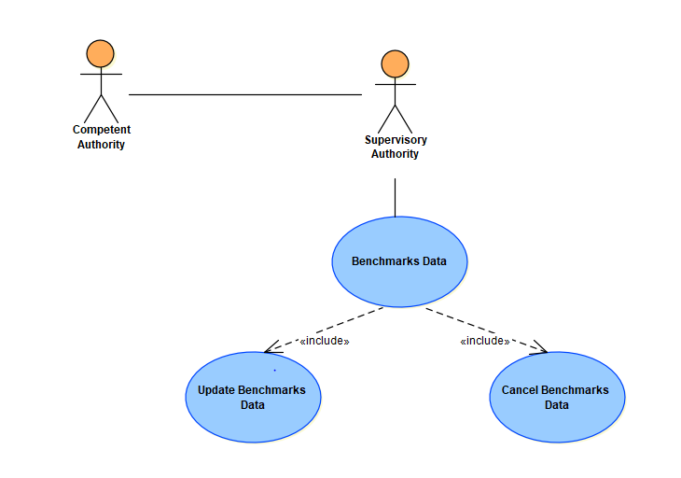

## Update Benchmarks Data

|  |  |
| --- | --- |
| Item | Description |
| Definition | The process of notifying Supervisory Authority of any update about information on Financial Parties/Benchmarks supervised by a NCA under the local regulation. It provides identification details, other information details and status detail under the local regulation. The notification is processed and validated by the Supervisory Authority who then update its public register accordingly. |
| Trigger | The process is triggered when:   * The status of a financial party acting as an administrator is changing under the local regulation as per the decision of the relevant NCA * A financial party acting is endorsing/is not endorsing anymore a Third Country benchmark with the agreement of the relevant NCA * Any details about Identifications, other information is changing upon verification or decision of the relevant NCA on a financial party under the local regulation * A benchmark is administrated/is not administrated anymore by an administrator supervised under the local regulation * A benchmark is endorsed by a financial party with the agreement of the relevant NCA. * Any details about Identifications, other information is changing upon verification or decision of the relevant NCA on a benchmark under the local regulation |
| Pre-conditions | The NCA has been notified of/decided on a change on the identification, general information data, status of the Financial Party/Benchmark under the local regulation. |
| Post-conditions | The NCA has been notified of the outcome in Supervisory Authority of its notification. |
| Role | NCA |

## Cancel Benchmarks Data

|  |  |
| --- | --- |
| Item | Description |
| Definition | The process of invalidating data, previously submitted in the past, about information on Financial Parties/Benchmarks supervised by a NCA under the local regulation. The notification is processed and validated by Supervisory Authority who then update its public register accordingly. |
| Trigger | The process is triggered when:   * Data on a Financial Party has been notified to Supervisory Authority following a reporting error * Data on a Benchmark has been notified to Supervisory Authority following a reporting error |
| Pre-conditions | The NCA has been notified of/decided on a change on the identification, general information data, status of the Financial Party/Benchmark under the local regulation. |
| Post-conditions | The NCA has been notified of the outcome in Supervisory Authority of its notification. |
| Role | NCA |

# Description of Business Activities

This section presents the different BusinessActivities within each BusinessProcess. BusinessActivities of a process are described in swim lane diagrams and are referred in this document as activity diagrams.

The development of an activity diagram is part of the ISO 20022 modelling process and allows capturing the requirements.

The activity diagram provides a zoom-in on the BusinessActivities taking place during each of the BusinessProcesses described in Section 4. It also shows the BusinessActivities that are triggered when another BusinessActivity has a negative result.

What is the activity diagram about?

* It is a diagram representing the ‘common lifecycle’ of a BusinessProcess
* A start point ⚫ shows where the lifecycle of the BusinessProcess commences and the end points show End point where the lifecycle may possibly end
* A lozenge means that a choice between several actions can be made
* A bar means that several actions are initiated in parallel
* The flow of activities between the involved Participants (parties)
* BusinessActivities may result in different actions, that is, information is conveyed from one party to another party.

Both in-scope and out-of-scope activities are included, with a different level of details. There are no information requirements for out-of-scope activities, except that they should be clearly identified in the diagram.

Activity diagrams are always accompanied with a text describing the BusinessActivities and their interactions.

 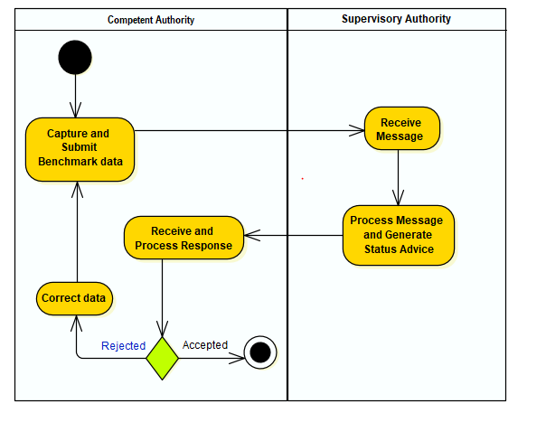

| **Description of the BusinessActivities** | |
| --- | --- |
|  | **Initiator** |
| Capture and Submit Benchmark’s administrator Data : Extract local data on administrator, create the message and submit it to Supervisory Authority based on the agreements that exist between the CA and Supervisory Authority | **CA** |
| Receive Message Supervisory Authority retrieves the submitted messages from the submission channel | **CA** |
| Process Message and Generate Status Advice: Each received message is checked for   * Completeness of message * Validity against previously submitted data   Once complete, generate the status advice file for sending back to CA | **SA** |
| Receive and Process Response: CA checks for and receives feedback on the message data they submitted. They download and process the status advice message to identify if any further actions need to be taken complete the data submission process. | **CA** |
| Corrective Action: CA must fix any issues that have been identified and if applicable, resubmit the message or incorrect records. | **CA** |

# BusinessTransactions

This section describes the message flows based on the activity diagrams documented above. It shows the typical exchanges of information in the context of a BusinessTransaction.

## BMR Financial party BusinessTransaction



* NCA submits a BMR Benchmark message to Supervisory Authority (Financial Supervised Party Identity Report) according to administrators.
* Supervisory Authority sends a status advice message to inform whether the message succeeded of of failed the validation (Financial Instrument Reporting Status Advice).

## BMR Benchmark BusinessTransaction



* NCA submits a BMR Benchmark message to Supervisory Authority (Financial Benchmark Report) according to benchmarks.
* Supervisory Authority sends a status advice message to inform whether the message succeeded of failed the validation (Financial Instrument Reporting Status Advice).

# Examples

This section describes business examples of the use of the various MessageDefinitions. Each example starts with a description of the example scenario followed by the actual MessageInstance.

## FinancialSupervisedPartyIdentityReport – auth.076.001.01

Description

This example describes a FinancialSupervisedPartyIdentityReport sent by a NCA containing the initial announcement of the recognition under the local regulation of a Third Country Administrator.

Example

* Reporting NCA: Central Bank of Ireland
* Validity start date: 02/03/2019
* Administrator identifier

Identifier of the Financial party at Central Bank of Ireland: 4978

* Other information

Administrator name: Standard and Poors

Country: United States

Type: Benchmark Administrator

National supervising Authority: US Commodity Futures Trading Commission

Official website URL: <https://wwww.stamdardandpoors.com/>

* Status detail

Status: Recognition under Art.32

Relevant EU/EE Authority: Central Bank of Ireland

Status effectivity date: 01/03/2019

Message Instance

>

<?xml version="1.0" encoding="UTF-8"?>

<n1:Document xmlns:xsi="http://www.w3.org/2001/XMLSchema-instance" xmlns:n1="urn:iso:std:iso:20022:tech:xsd:auth.076.001.01" xsi:schemaLocation="urn:iso:std:iso:20022:tech:xsd:auth.076.001.01 auth.076.001.01.xsd">

<n1:FinSprvsdPtyIdntyRpt>

<n1:PtyData>

<n1:Upd>

<n1:Id>

<n1:Id>

<n1:PrtryId>

<n1:Id>4978</n1:Id>

<n1:Issr>IE</n1:Issr>

</n1:PrtryId>

</n1:Id>

</n1:Id>

<n1:Othr>

<n1:FullNm>Standard and Poors</n1:FullNm>

<n1:Ctry>US</n1:Ctry>

<n1:PtyTp>BCHA</n1:PtyTp>

<n1:SprvsgAuthrty>

<n1:PrtryId>IECB</n1:PrtryId>

</n1:SprvsgAuthrty>

<n1:Ctct>

<n1:URLAdr>https://wwww.stamdardandpoors.com/</n1:URLAdr>

</n1:Ctct>

</n1:Othr>

<n1:Sts>

<n1:CmptntAuthrty>

<n1:Id>

<n1:PrtryId>USCF</n1:PrtryId>

</n1:Id>

</n1:CmptntAuthrty>

<n1:StsRsn>ARCG</n1:StsRsn>

<n1:ActvtyPrd>

<n1:Dt>2019-03-01</n1:Dt>

</n1:ActvtyPrd>

</n1:Sts>

<n1:TechVldtyPrd>

<n1:Dt>2019-03-02</n1:Dt>

</n1:TechVldtyPrd>

</n1:Upd>

</n1:PtyData>

</n1:FinSprvsdPtyIdntyRpt>

</n1:Document>

## FinancialBenchmarkReport – auth.077.001.01

This example describes a FinancialBenchmarkReport sent by a NCA containing the initial announcement of a benchmark administrated by the Financial Party reported as per section 7.1 which is recognised under the local regulation.

Example

* Reporting NCA: Central Bank of Ireland
* Validity start date: 02/03/2019
* Benchmark identifier

Identifier of the benchmark at Central Bank of Ireland: 1234

ISIN: US78378X1072

* Other information

Name: S&P 500

* Administrator detail

Administrator identifier at Central Bank of Ireland: 4978

* Status detail

Status: Recognition under Art.32

Relevant EU/EE Authority: Central Bank of Ireland

Status effectivity date: 01/03/2019

Message Instance

<?xml version="1.0" encoding="UTF-8"?>

<n1:Document xmlns:xsi="http://www.w3.org/2001/XMLSchema-instance" xmlns:n1="urn:iso:std:iso:20022:tech:xsd:auth.077.001.01" xsi:schemaLocation="urn:iso:std:iso:20022:tech:xsd:auth.077.001.01 auth.077.001.01.xsd">

<n1:FinBchmkRpt>

<n1:BchmkData>

<n1:Upd>

<n1:Id>

<n1:ISIN>US78378X1072</n1:ISIN>

<n1:OthrId>

<n1:Id>1234</n1:Id>

<n1:Tp>

<n1:Cd>IE</n1:Cd>

</n1:Tp>

</n1:OthrId>

</n1:Id>

<n1:Othr>

<n1:FullNm>S&P 500</n1:FullNm>

</n1:Othr>

<n1:Admstr>

<n1:Id>

<n1:PrtryId>

<n1:Id>4978</n1:Id>

<n1:Issr>IE</n1:Issr>

</n1:PrtryId>

</n1:Id>

</n1:Admstr>

<n1:Sts>

<n1:CmptntAuthrty>

<n1:Id>

<n1:PrtryId>IECB</n1:PrtryId>

</n1:Id>

</n1:CmptntAuthrty>

<n1:StsRsn>ARCG</n1:StsRsn>

<n1:ActvtyPrd>

<n1:Dt>2019-03-01</n1:Dt>

</n1:ActvtyPrd>

</n1:Sts>

<n1:TechVldtyPrd>

<n1:Dt>2019-03-02</n1:Dt>

</n1:TechVldtyPrd>

</n1:Upd>

</n1:BchmkData>

</n1:FinBchmkRpt>

</n1:Document>

# Revision Record

|  |  |  |  |  |
| --- | --- | --- | --- | --- |
| **Revision** | **Date** | **Author** | **Description** | **Sections affected** |
| V0 | 26 June 2018 | ESMA | First draft | All |
| V1 | 29 June 2018 | ISO 20022 RA | Review before publication | All |
|  |  |  |  |  |
|  |  |  |  |  |
|  |  |  |  |  |
|  |  |  |  |  |

**Disclaimer**:

Although the Registration Authority has used all reasonable efforts to ensure accuracy of the contents of the iso20022.org website and the information published thereon, the Registration Authority assumes no liability whatsoever for any inadvertent errors or omissions that may appear thereon. Moreover, the information is provided on an "as is" basis. The Registration Authority disclaims all warranties and conditions, either express or implied, including but not limited to implied warranties of merchantability, title, non-infringement and fitness for a particular purpose.

The Registration Authority shall not be liable for any direct, indirect, special or consequential damages arising out of the use of the information published on the iso20022.org website, even if the Registration Authority has been advised of the possibility of such damages.

**Intellectual Property Rights**:

The ISO 20022 MessageDefinitions described in this document were contributed by ESMA. The ISO 20022 IPR policy is available at www.ISO20022.org > About ISO 20022 > Intellectual Property Rights.

1. https://eur-lex.europa.eu/legal-content/EN/TXT/?uri=CELEX%3A32016R1011.
2. The requirement to use ISO 20022 does not however apply to the reporting between trade counterparties and Trade Repositories